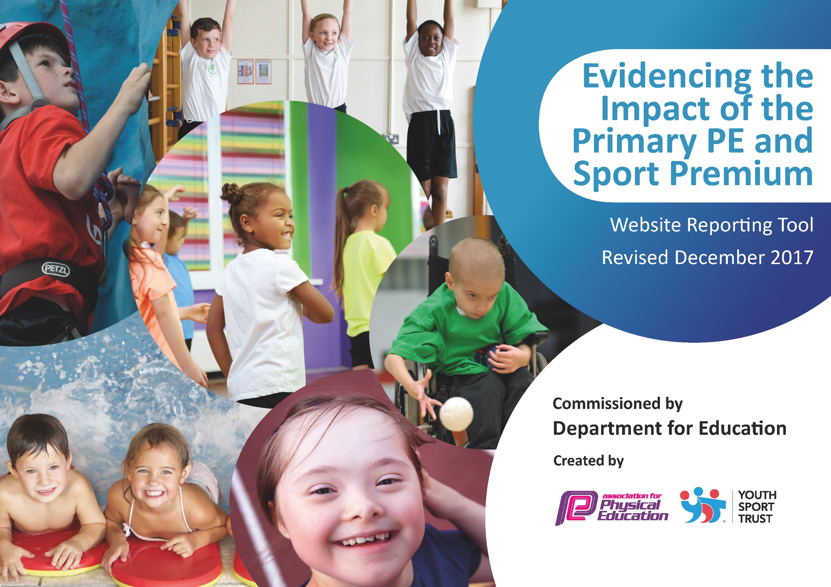

Schools must use the funding to make additional and sustainable improvements to the quality of PE and sport they offer. This means that you should use the Primary PE and Sport Premium to:

- develop or add to the PE and sport activities that your school already offers
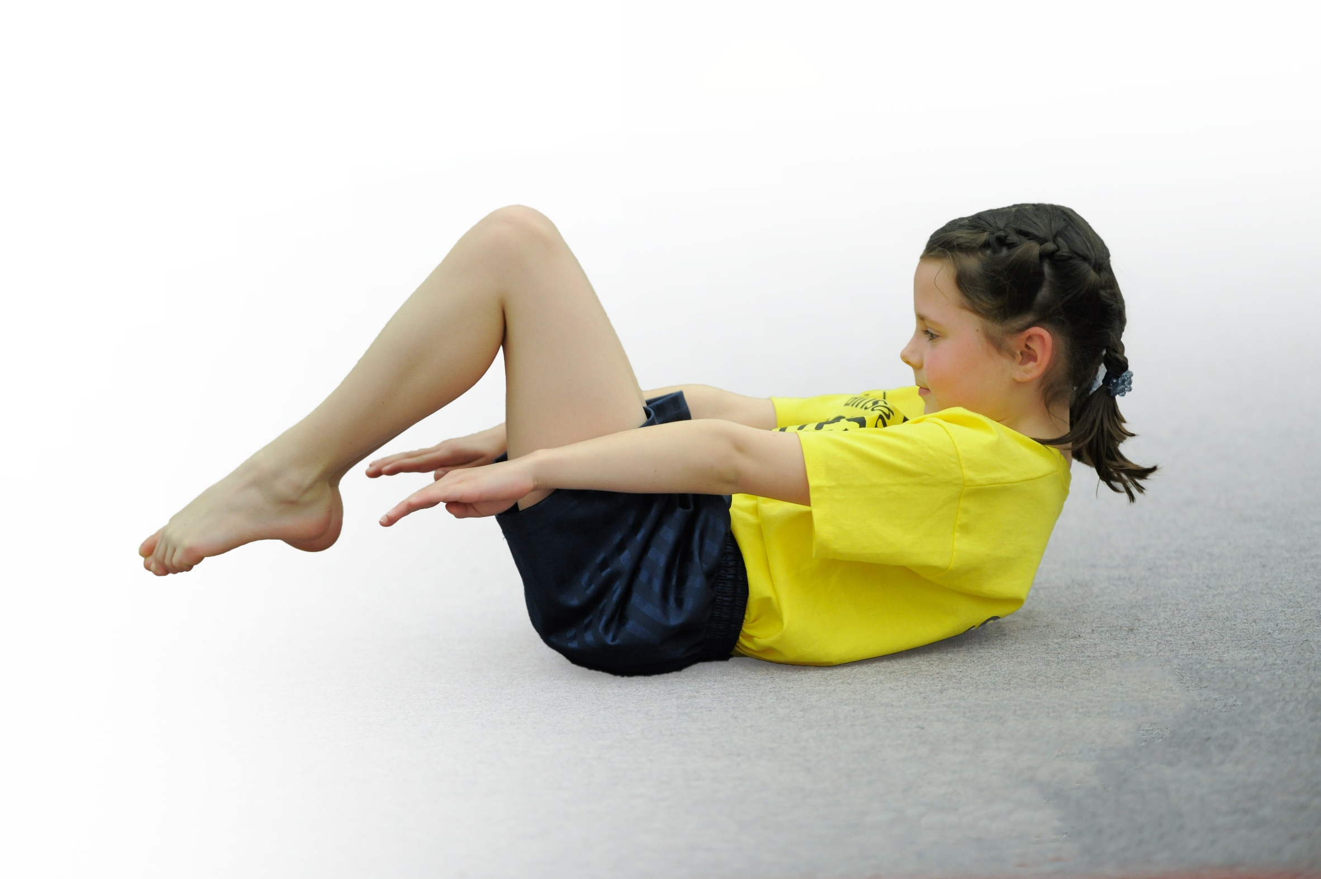
- build capacity and capability within the school to ensure that improvements made now will benefit pupils joining the school in future years

Please visit gov.uk for the revised DfE guidance including the 5 key indicators across which schools should demonstrate an improvement. This document will help you to review your provision and to report your spend. DfE encourages schools to use this template as an effective way of meeting the reporting requirements of the Primary PE and Sport Premium.

We recommend you start by reflecting on the impact of current provision and reviewing the previous spend.
Under the Ofsted Schools Inspection Framework, inspectors will assess how effectively leaders use
the Primary PE and Sport Premium and measure its impact on outcomes for pupils, and how effectively governors hold them to account
for this.

Schools are required to publish details of how they spend this funding as well as on the impact it has on pupils’ PE
and sport participation and attainment.
We recommend regularly updating the table and
publishing it on your website as evidence
of your ongoing review into how you are using the money
to secure maximum, sustainable impact. To see an example of how to complete the table please click HERE.

Support for review and reflection - considering the 5 key indicators from DfE, what development needs are a priority for your setting and your students now and why? Use the space below to reflect on previous spend, identify current need and priorities for the future.

Key achievements to date: | Areas for further improvement and baseline evidence of need:
- Enabling every year group to have the expertise of a coach for at least one PE lesson each week.  - Participation in a variety of after school competitions as well as 11 football team tournaments.  - Four after school clubs running every week and full 90% of the time.  - CPD carried out for NQT | - Enhancing the opportunities for our less active and other targeted groups  - Introducing new ideas to achieve the recommended 30 minutes a day of activity – including the 15 minutes mile daily.  - Providing more opportunities for non-traditional sports and inspirational sessions for all – fencing and archery  - Increasing the competition participation to over 50%  - Building an area to encourage sports all year round.  - Introduce something new for dance e.g. Zumba and cheerleading  - Introduce professional coaching during swimming lessons for all groups  - CPD for all teachers

Meeting national curriculum requirements for swimming and water safety | Please complete all of the below*:
What percentage of your current Year 6 cohort swim competently, confidently and proficiently over a distance of at least 25 metres? | 49%
What percentage of your current Year 6 cohort use a range of strokes effectively [for example, front crawl, backstroke and breaststroke]? | 42%
What percentage of your current Year 6 cohort perform safe self-rescue in different water-based situations? | 2%
Schools can choose to use the Primary PE and Sport Premium to provide additional provision for swimming but this must be for activity over and above the national curriculum requirements. Have you used it in this way? | Yes/No  However school has decided to send sports coaches swimming to support staff and enhance the swimming curriculum.
*Schools may wish to provide this information in April, just before the publication deadline.

Action Plan and Budget Tracking
Capture your intended annual spend against the 5 key indicators. Clarify the success criteria and evidence of impact that you intend to measure to evaluate for students today and for the future.

Academic Year: 2018/19 | Total fund allocated: £4,000 | Date Updated: 17/09/18
Key indicator 1: The engagement of all pupils in regular physical activity – Chief Medical Officer guidelines recommend that primary school children undertake at least 30 minutes of physical activity a day in school |  |  |  | Percentage of total allocation:
 |  |  |  | 25%
School focus with clarity on intended impact on pupils: | Actions to achieve: | Funding allocated: | Evidence and impact: | Sustainability and suggested next steps:
Purchase Television on Key stage one playground for before school, playtime and lunch time activities,  - Enables staff to deliver a more precise lesson with the aid of resources  - Creates calmer lunchtimes with less arguments or fights  - Increases pupil participation in activities  - Increases interest in sport and a healthy lifestyle  - Prepares children for their daily learning  - Provides a broad experience of a range of sports and activities | Regular check that the contents are changed and activities are engaging children.  PE lead to talk to staff to check what they feel is used the most and then source the videos.  All class teachers and office staff took part in training to upload new content on the TV. | £4,000 | More children are participating in sport during lunch times
Key indicator 2: The profile of PE and sport being raised across the school as a tool for whole school improvement |  |  |  | Percentage of total allocation:
 |  |  |  | 50% plus carry forward
School focus with clarity on intended impact on pupils: | Actions to achieve: | Funding allocated: | Evidence and impact: | Sustainability and suggested next steps:
To build a 3G caged area  - Allows the children to take part in ball games when field is too wet or slippery.  - Aids towards increasing pupil participation in competitive sport  - Raises the profile of PE across the school  Also fits in with key indicators 4 and 5 | Make sure that staff are utilizing the pitch during PE lesson and break time.  Make sure lunchtime supervisors and utilizing the pitch. | Remainder of Sports Premium 2017/18 plus some school fund.

Key indicator 3: Increased confidence, knowledge and skills of all staff in teaching PE and sport |  |  |  |  | Percentage of total allocation:
 |  |  |  |  | 1%
School focus with clarity on intended  impact on pupils: | Actions to achieve: |  | Funding  allocated: | Evidence and impact: | Sustainability and suggested  next steps:
NQT’s to be offered a six week coaching sessions with BACT to support in the teaching of PE to help support the teacher in the beginning of their career.  - Provides a broad experience of a range of sports and activities  - The cricket coaching sessions culminate in a cricket afterschool club and teacher accessing an online cricket reward scheme.  Pupils taught by their class teacher who is confident with teaching dance. | BACT staff to arrange this directly with NQT’s and to operate it on a rolling program.  BACT carried out training on class teachers for dance. |  | £300
Key indicator 4: Broader experience of a range of sports and activities offered to all pupils |  |  |  |  | Percentage of total allocation:
 |  |  |  |  | 24%
School focus with clarity on intended  impact on pupils: |  | Actions to achieve: | Funding  allocated: | Evidence and impact: | Sustainability and suggested  next steps:
Four after school clubs covering a wide range of different sports including dance and to be offered to each key stage including Reception. |  | Burton Alboin Community Trust (BACT) to run each club to ensure that well trained staff are delivering the clubs. | £3,900 | Increased participation in the after school clubs. | School council to have decide with the learning mentor on the clubs to be offered.  A girls football and a dance to be help on a Monday evening.  A football coaching session to be offered on a Friday lunchtime.
  - Includes the Foundation children in the chance for a coach to teach them
  - Provides a broad experience of a range of sports and activities
  - Adds to the ELG provision for Physical Development – Moving and handling enabling them to:
  -  Show good control and coordination in large and small movements
  -  To move confidently in a range of ways safely negotiating space
  - Helps to improve important motor skills
  - Teaches the children an important life skill
  - Increases pupil motivation.
  - Raises standard of pupil performance
Key indicator 5: Increased participation in competitive sport |  |  |  |  | Percentage of total allocation:
 |  |  |  |  | 2%
School focus with clarity on intended  impact on pupils: | Actions to achieve: |  | Funding  allocated: | Evidence and impact: | Sustainability and suggested  next steps:
Pay for competitions and the cost of coaches/minibus’ to get there if all other transport fails  - Increases pupil motivation  - Enhances our inclusive provision  - Enhances a positive attitude and engagement in and towards competition  - Increases our links and partnerships with other schools  - Raises the profile of PE across the school  After school to run in line with up and coming competitions to ensure children are confident in the sport.  Also fits in Key Indicator 2 | Go through the list of competitions from Blessed Robert Sutton, BACT and East Staffs Partnership.  - Ensure all year groups have a competition to go  - Ensure a range of sporting types are entered  - Put the dates on the calendar and inform staff |  | £400 competition fees £300 to join the group and 2 x £50 for non-qualifying competition.  £40 per competition for Taxis  (12 competition in 2017/18) | - A variety of children have participated in competitions and children who normally don’t take part are encouraged to do so.  - The sports display board in the hall to display competition  - Newsletters have advertised these

