Geography Policy


River View Primary and Nursery School

Made- June 2022
Reviewed –June 2023

Introduction
Geography at River View must be taught to all children and allow children to explore the relationship between the Earth and its people. Teaching should equip pupils with knowledge about diverse places, people, resources and natural and human environments, together with a deep understanding of the Earth’s key physical and human processes. As pupils progress, their growing knowledge about the world should help them to deepen their understanding of the interaction between physical and human processes, and of the formation and use of landscapes and environments. Geographical knowledge, understanding and skills provide the frameworks and approaches that explain how the Earth’s features at different scales are shaped, interconnected and change over time.

Aims
The aim of Geography at River View are:
- To develop a curiosity for the world around them and beyond and to build on their cultural capital.
- To develop contextual knowledge of the location of globally significant places local to the children and globally.
- The geographical skills that we intend to teach are:
- Collect, analyse and communicate with a range of data gathered through experiences of fieldwork that deepen their understanding of geographical processes
- Interpret a range of sources of geographical information, including maps, diagrams, globes, aerial photographs and Geographical Information Systems (GIS)
Curriculum
We follow a Prospectus scheme where lessons are mapped out following the National Curriculum to guide learning objectives and where geographical skills are adapted and developed. Our curriculum allows our pupils to learn and to gain geographical expertise. We have a clear mapped out journey starting in EYFS and developing through our key stages. This is critical if pupils are to move towards becoming experts in geography.
EYFS
Early years explore geographical themes in line with the EYFS framework under the Understanding the World heading. Children are guided in learning jobs to develop a sense of their physical world, as well as their community, through opportunities to explore, observe and find out about people, places, technology and the environment. The key knowledge and skills in reception provide the foundation to those 5 identified in phase 1 and specifically Y1. Children are assessed according to the Development Matters Attainment targets.

KS1
Pupils should develop knowledge about the world, the United Kingdom and their locality. They should understand basic subject-specific vocabulary relating to human and physical geography and begin to use geographical skills, including first-hand observation, to enhance their locational awareness.
Children should be taught:
- Location knowledge
- Place knowledge
- Human and physical geography
- Geographical skills and fieldwork
KS2
Pupils should extend their knowledge and understanding beyond the local area to include the United Kingdom and Europe, North and South America. This will include the location and characteristics of a range of the world’s most significant human and physical features. They should develop their use of geographical knowledge, understanding and skills to enhance their locational and place knowledge.
Children should be taught:
- Location knowledge
- Place knowledge
- Human and physical geography
- Geographical skills and fieldwork

Geography Curriculum Planning and organisation
We are a two form entry school where Geography is taught under the theme of “I wonder..” Lessons. Each year group will follow the Prospectus plan of lessons and make sure that the children know the difference between the different subjects. This will allow children to have a continuum of lessons which build on prior knowledge.
EYFS will be changing topics every half term whereas the rest of the school will be changing topics termly. See the Long Term Plans on the website to get a better understanding of this.
Geography Co-ordinator
The Geography co-ordinator leads the maintenance and development of the subject.
They are responsible for assuring quality and standards in the subject by:
- Taking the lead in the development, evaluation and amendment of schemes of work as and when necessary.
- Identifying training needs of staff through monitoring and performance management review.
- Acting as a consultant to colleagues on resources, fieldwork possibilities, curriculum changes, classroom teaching ideas.
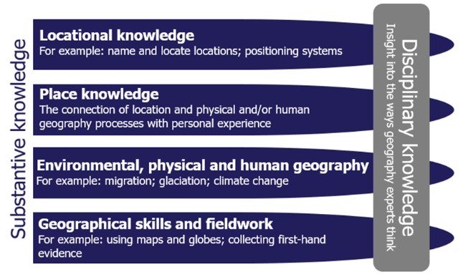
- Monitoring and evaluating pupils’ work and classroom teaching.

Monitoring and Assessment
Class teachers will be accountable for group assessment of their pupils. The GeogrGeography will be monitored by SLT and the Geography co-ordinator by completing learning walks, book scrutinises and pupil voice evaluations.
Resources
Staff are aware of the resources that we have in school and where to find them. There is a range of differentiated atlases for children at access. Staff are aware of different maps and websites to use for getting the best progress out of the children.

