
River View Primary and Nursery School

Forest school’s policy

This policy is in place to protect and monitor Riverview Primary and Nursery schools forest schools provision. This policy outlines risk assessments, aims of forest schools and the key elements required from children, staff and parents.

Introduction
Forest schools is a new initiative within Riverview Primary and Nursery school for the academic year 2018-2019. Forest schools is a specific type of outdoor education which aims to improve the holistic development of children. From research, forest schools have shown that children who participate are more likely to have improved self-esteem, confidence and awareness of the natural world.

Aims
By undertaking forest schools, Riverview aims to improve the self-awareness, self-confidence and self-esteem of the children we teach. We aim to equip the children with an understanding and respect of the natural world and their local area, through given them time to explore and learn about the importance of the natural world and how to care for it. We aim to provide children with outdoor experiences to enrich their education and learning environment, where they can work collaboratively and individually to develop a range of skills. It is important to us that the children learn about the natural world and how to look after this.

The main forest school principles are to ensure that environmental awareness and impact are taught, encouraging conservation of the environment around us. Children and adults will make sure respect is shown to the natural environment and develop skills which will enhance the provision.

Policies
The forest schools provision will take into account the following policies already in place at Riverview:
- Health and safety policy
- Behaviour policy
- Safeguarding policy
- Equalities policy
- Inclusion policy
- Risk assessment policy
- Medical and medicine policy
The following policies will also be put into place:
- Fire safety policy
- Tool use policy

Health and safety policy
Forest school leaders will adhere to the school’s health and safety policy. We will take necessary safety talks and discussions with the children and encourage them to begin to risk assess for themselves alongside the adults. Adults will carry out thorough risk assessments and monitor the children and forest school area regularly.
A forest school (site and tool) risk assessment has been carried out and will be attached to this policy, alongside a risk benefit analysis form, which outlines the main importance of the children being exposed to risk and how this benefits their learning.
Both forest school leaders have up to date first aid certificates and all curriculum area learning supervisors (which may attend with their classes) also have current first aid certificates. Emergency contact details will be held at the office and if an accident occurs which needs assistance another member of staff will obtain the school phone/site manager.
Fires and tools are a key part of forest schools, however these will be only used in accordance with policies written alongside the forest school’s policy and SLT will be aware when tools/fires will be in use.

Safeguarding
Forest schools will be delivered by members of the staff (either a qualified teacher or HLTA with assistance from other staff members), all have current up to date CRB/DBS checks. Everyone involved will have access to the risk assessments and will be aware of the school policies and will follow these accordingly. Any safeguarding concerns will follow the same procedures as within the school building. Concerns will be admitted to MyConcern and the safeguarding officers will be made aware of these.

Equality and Inclusion
All adults, staff and children are treated equally and with dignity. All children will be given opportunities to access the equipment and activities (with the support and guidance they require). Children will be given the respect and encouragement needed to allow them to achieve.

Behaviour Policy
Riverview Primary and Nursery school’s behaviour policy will be consistent within the forest school’s sessions. A lot of praise and rewards will be given to the children, the activities will aim to provide self-satisfaction and achievement also. If a child is a danger to themselves or others and are not abiding by warnings, they may be returned into school for a period of time (timeout etc.).
Emergency action plan
In the event of an emergency/accident and a child/adult needs first aid treatment, a member of staff (first aid trained) would see to the person requiring first aid, whilst the other member of staff supervises the other children (checking they are all present and safe) as well as sourcing help from other members of staff within school.

If a child needs emergency medical treatment an ambulance will be called as well as parents/guardians of the children. Accident and Incident forms will be completed for major and minor incidents when in school and logged within the medical form folder (within the staffroom). Any incidents/accidents will be logged and will follow the school’s procedure of informing parents, the class teacher will be responsible for relaying information to parents.

Risk assessments
Risk assessments are in place to cover the following:
- The site
- Tool use
- Fire lighting
- Cooking
- Activities involving wood/the area

These risk assessments can be found below and will be adhered to by all staff involved. Safety checks will be carried out before each forest school session and any amendments/safety precautions to the risk assessment will be carried out. The site will be checked regularly and will be maintained to allow the site to be a safe learning environment for the children. Any concerns about the site will be logged and reported to the site manager to assess.

Using tools/fire lighting will be carried out under the supervision of a forest school leader qualified to level 3 (Miss R Holmes or Mrs P Whitley). The use of tools or fire will be monitored carefully and be supervised in a designated area designed for tool use/fire use. Tool talks will be given each time a tool is to be used, good practice when using the tools will be shown. No other staff member will be able to support tool use unless trained to level 3 (designated staff above). All tools and equipment will be safely stored away after use. All resources and equipment will be regularly checked and monitored.
When fires are lit, it will be one of the forest school leader’s responsibility for manning the fire and ensuring the safety procedures are carried out.
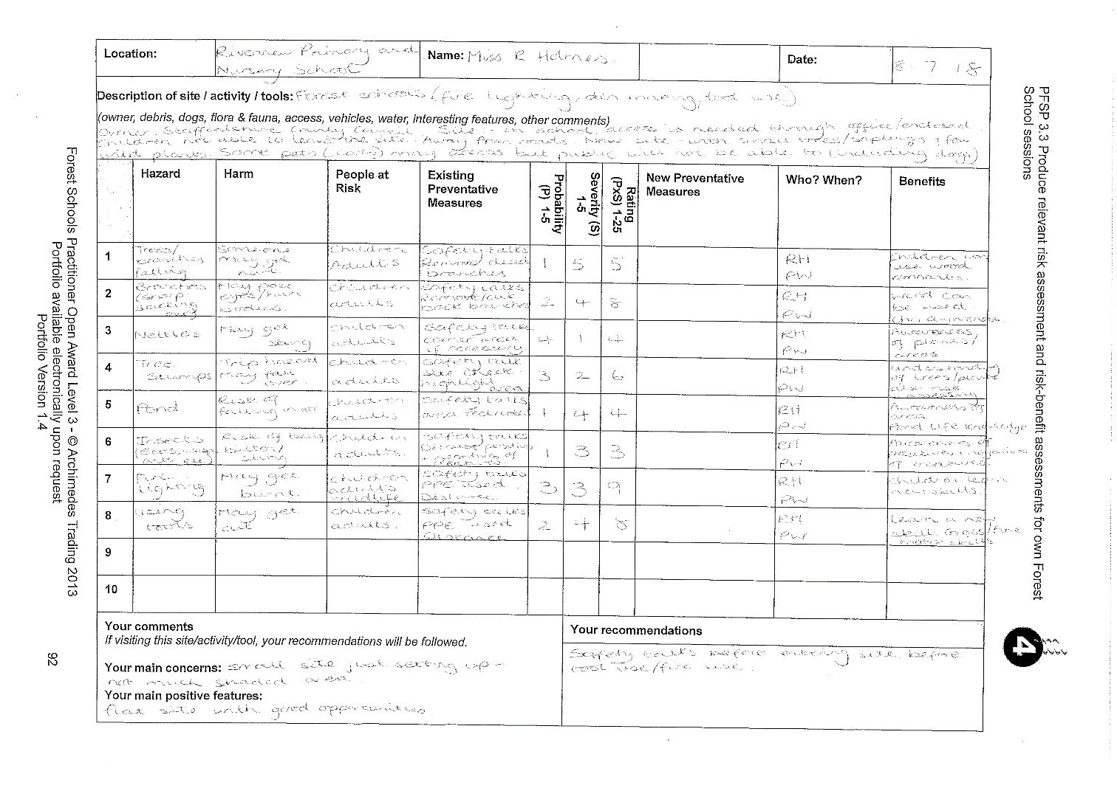
Scenarios | Benefit Analysis | Management of Risk
Uneven ground when exploring site. Ground not level built up in some places. Twigs, leaves and roots breaking the ground. Tree stumps on ground. | Encourages children to become self-aware and understand the surroundings. Children are becoming more familiar with geography terrains and the outside world. | Children will always have a safety talk before tasks/start of forest schools. Both forest school leaders are first aid trained. Other adults (classroom staff) will be around to observe and watch children.
Falling branches, leaves and sticks from trees/sky. | Children are aware of natural surroundings and begin to risk assess for themselves. | Safety talk before forest school’s session. Site checked regularly before and after each session.
Bites and stings (insects) | Children are aware of natural environment and the eco-system (insects). Able to inform children of insects and the way they move and how they defend themselves/functioning. | Discuss the risks of insects such as bees, in a positive way to enable children not to be scared. Long armed/trousers clothing to be worn to avoid risk of stings/bites. Warn children not to catch bees/wasps or chase them.
Stings from plants (nettles) | Children are self-aware and aware of the natural environment. Children have an understanding of plants they can touch and what to look for within plants. | Safety talk, dangers of touching nettles but also what to do if they get stung. Long armed/trousers clothing to be worn. Warn children of the possibilities of being stung at a low level.
Children wandering off from site | Children will build up positive relationships with others. They will understand boundaries and following rules. | Boundaries discussed with the children and the importance of sticking to boundaries. Children cannot get out of school grounds. Regular head counts and call backs to check everyone is together.
Allergies or medical conditions | Promote independence in children and the understanding of allergies and what to avoid. Developing self-awareness. | All adults aware of medical conditions/allergies and aware of how to treat if required. All adults must have seen care plans beforehand (class teacher responsible for showing these).
Fungi/fruits/mushrooms growing on trees/bushes/ground | Promote awareness that not everything can be eaten. Encourage independence and ability to identify common plants/fruits/mushrooms etc. Make sure children are aware of what is growing around them. | Ensure children are aware that some fruits/mushrooms are not edible and should not be eaten if they are not identified. Adults to regularly check the site and be aware of what is growing. Ensure children do not eat anything without adult permission.
Using sticks, branches and sharp objects (such as building dens) | Children have opportunities to team build and work as a group. Using problem solving skills to make different shaped dens. Children have access to learn and practice a range of knots. Opportunities to develop motor skills, creative skills and also social skills. | Children to hold sticks by their sides (if able) so people do not run into them. Children have an awareness of suitable ways to carry equipment of different sizes. First aiders (leaders) available if accidents do occur. Safety talks beforehand.
Animal Faeces | To understand the importance of hygiene. To have an awareness that leaving droppings shows animal traits (such as where they are living etc). | Make children aware that animals are living nearby and may have left droppings. Make sure they do not pick any up any they are aware of this. Children to wash hands properly after forest school sessions. Site regularly checked.
Branches with sharp edges, thorns, or spiky bushes etc. | Children to self-assess risks and be self-aware of the area around them. Encourage self confidence in environment and ability to support peers in managing risks. | Children and adults to be aware of potential risks. Any cuts/injuries to be dealt with (forest school leaders/first aiders).
Using string/ropes to make knots/dens or for creativity | Children to develop motor skills. Children to learn knot techniques and how to use these. They are learning new skills and developing being able to follow instructions. Develops and encourages creativity. | Children to be shown safe ways to use ropes/string and how to use these purposefully. Children to be taught knot skills. Children to be supervised when making dens (connecting ropes etc).
Using small tools such as potato peelers and knives. | Children are developing real life experiences and learning new skills. They are able to develop independence and confidence. Children will improve and practice their motor skills. | Children to be shown how to use safely and responsibly. Safety talks to be give before every tool use. Supervision of the children.
Using larger tools (bowsaw, loppers, bill hook etc). | Children are developing real life experiences and learning new skills. They are able to develop independence and confidence. Children will improve and practice their motor skills. Children to develop communication and listening skills (working together with tools). Children to develop hand eye coordination and understanding of risk assessing. | Children to be shown how to use safely and responsibly. Safety talks and tool talks to be give before every tool use. Supervision of the children. Protective PPE to be worn (i.e gloves on helping hand). Children to be supported with an adult when using the tools. Only forest school leaders to be supporting children using tools.
Fire lighting/camp fires | Children to develop fire awareness. Developing trust and confidence in others. To build team building. Children to learn new skill- fire lighting. Develop understanding of proximity and surroundings. Children to have an awareness of danger and risks as well as how to manage these. Children able to identify a range of useful natural materials which can be used for fire lighting. | Safety talks given before any fire or fire lighting. Awareness of camp fire/circle and the ways in and out as well as emergency exits. Children aware of how to move around the fire. Protective PPE to be used (gloves on helping hand). Water always available and next to the fire in case of emergency. Tinder and kindling to be collected before a fire is lit. Children on enter the centre of the fire circle by request. Only trained forest school leaders to construct fires with children and ensure school are aware prior to fire lighting. Have emergency plan if fire gets out of hand- evacuate children and call 999.
Cooking on a camp fire | Children are able to develop life skills and cooking skills. Children to gain an understanding of healthy eating. Children gain a sense of independence and satisfaction when completing cooking. | See fire lighting and camp fires. Adult supervision during cooking. Safety talks as above. Ensure food is cooked thoroughly and cooled before eating.
Using a Kelly Kettle | Children are able to develop life skills and become self-sufficient. Gain an understanding of how to safely prepare warm/clean water. Gain independence and an awareness of cooking. | Safety talks prior to using the Kelly kettle. Equipment (tinder and kindling) collected before lighting the fire for the Kelly kettle. Children to be supervised. Warnings over boiling water to be discussed. Ensure the bung is out of the top of the kettle before boiling (to stop explosion/overheating). Ensure correct PPE to be worn- glove on helping hand etc.

Key Considerations
Before each session, a check of the site will be carried out in line with the risk assessment. A first aid kit, wipes and inhalers will be taken to each session (this is the responsibility of the forest school leaders and class teachers). Children should wear the recommended clothing (outlined in the forest school leaflet) to ensure children’s safety. During sessions, children will be working in whole class/session groups, in small groups, pairs and sometimes 1:1 with an adult during tool use etc. this will be dependent upon the activities carried out. Equipment will be stored correctly after sessions and children will be encouraged to wash hands after sessions.

Sessions will be altered/cancelled if there is a risk of high winds, this is due to the safety risks posed to the adults and children. Forest schools cannot take place without the supervision of a qualified forest school level 3 leader (Miss Holmes or Mrs Whitley).

Before sessions, all children will be encouraged to use the toilets, if they need the toilet during sessions, they will be sent to the ones in school closest to where they are on site.
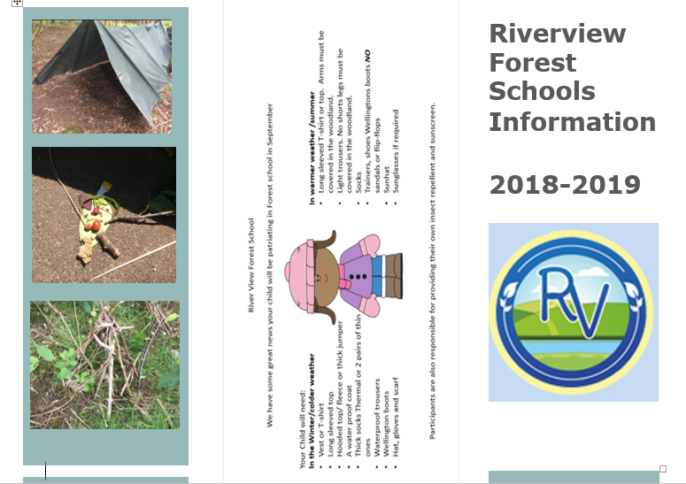

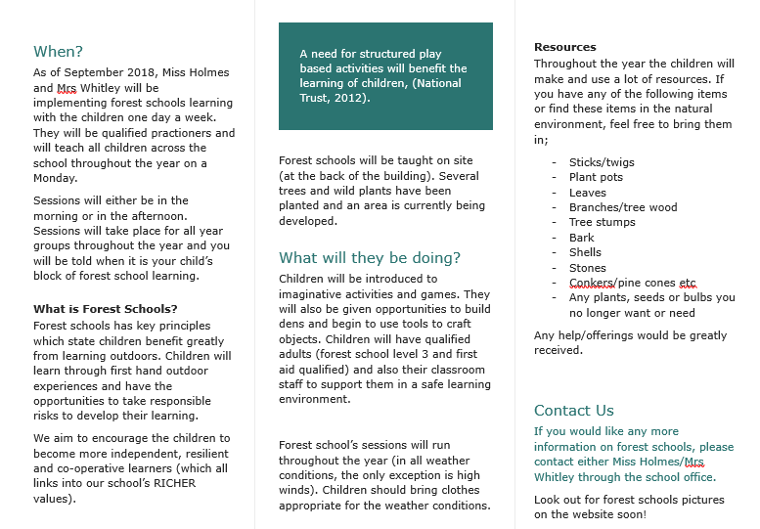

Agreed by:

