This term our science topic will be ’Ourselves’.
Here is some key vocabulary that we will be using.
Key Vocabulary  English | Key Vocabulary  Latvian | Picture
backbone | mugurkauls | 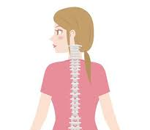
carnivores | gaļēdāji | 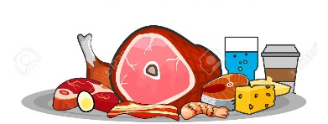
omnivore | visēdājs | 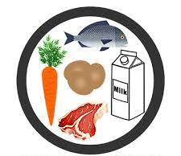
herbivore | zālēdājs | 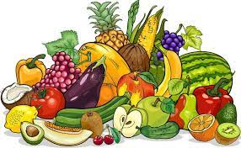
gills | žaunas | 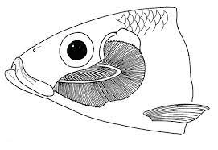
invertebrate | bezmugurkaulnieks | 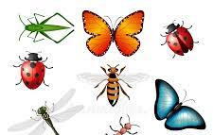
vertebrate | mugurkaulnieks | 

