Basic Hygiene Precautions in School – COVID-19
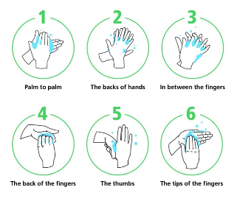
Personal hygiene
All staff and students/pupils must wash their hands thoroughly for a minimum of 20 seconds with warm water and soap on arrival at school. It may be necessary to supervise younger pupils to ensure this is completed.
All staff and students/pupils must ensure that they maintain high levels of personal hand hygiene throughout the day, washing hands for a minimum of 20 seconds with warm water and soap following use of the bathroom and before eating or preparing any food.
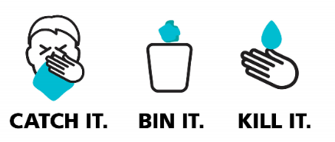
Disposable tissues should be available in classrooms should staff, students/pupils require them to catch coughs, sneezes and to blow their noses. Following use, tissues should be immediately disposed of into a bin or by the individual flushing it down a toilet.
Following coughing, sneezing or nose blowing, hand washing should be encouraged. If it is not practical for staff to leave a classroom to do this, hand sanitiser should be available and used.
Schools must ensure that they have a sufficient supply of:
- Dispensable soap
- Hand dryers/paper towels
- Disposable tissues
- Hand sanitiser (for staff as a minimum)
- Plastic bin bags
General classroom hygiene
So far as is reasonably practicable, students/pupils should be seated at the same desk within classrooms and not move and swap seats.
In secondary schools, consideration should be given as to whether lessons can be taught in the same classroom or in a smaller number of classrooms with staff rather than pupils moving around. If this cannot happen, desks should be wiped in between lessons with a suitable antibacterial product.
If teachers are moving around classrooms, suitable and sufficient antibacterial wipes should be available for staff to wipe IT equipment prior to use.
Staff and students/pupils should have their own pens/pencils for use and avoid the use of communal resources unless absolutely necessary. If communal resources are required, they should be sanitised before and after use.
If the weather permits, having a window open to support air change within classrooms would be good practice.
Schools must ensure that they have a sufficient supply of:
- Pens/Pencils and other essential resources
- Antibacterial wipes/spray sanitiser (STAFF USE ONLY)
General cleaning
General cleaning practices within schools should continue with increased sanitising of touch points such as door handles, light switches, touch screens and handrails etc. using a suitable disinfecting product from your usual supply chain.
Desks and hard surfaces should be cleaned daily using a suitable sanitising product from your usual supply chain.
General cleaning of washrooms remains unchanged and should continue as normal with daily cleaning.
General hoovering and mopping tasks remain unchanged and should continue as normal.
It is advised that cleaners where disposable gloves for any “wet” tasks or disinfecting. Disposable gloves must be changed between general areas, food areas and washrooms.
Gloves should be removed carefully with hands washed for a minimum of 20 seconds with warm water and soap in between glove changes and at the end of the shift.
Removing gloves safely:
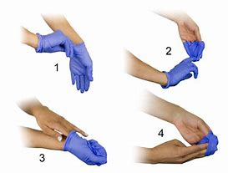
Gloves should be immediately placed in a bin once removed.
Schools must ensure that they have a sufficient supply of:
- Disposable gloves
- General cleaning and disinfectant products
- Disposable aprons (good practice to protect clothing but must be changed between general areas, food areas and washrooms.

Cleaning after a suspected or confirmed COVID -19 case
If there is a suspected or confirmed case of COVID-19 additional deep cleaning will need to be undertaken – see latest government guidance
https://www.gov.uk/government/publications/covid-19-decontamination-in-non-healthcare-settings/covid-19-decontamination-in-non-healthcare-settings

