This term our science topic will be ’electricity’.
Here is some key vocabulary that we will be using.
Key Vocabulary  English | Romanian | Picture
Electricity | Electricitate | 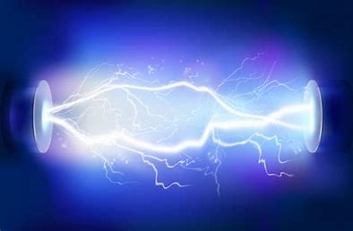
Appliance | Aparat | 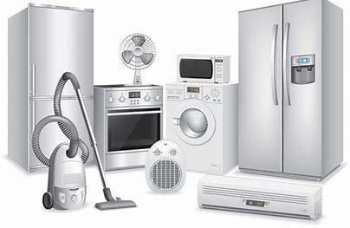
Mains | Rețea | 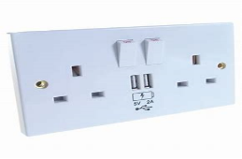
Conductor | Conductor | 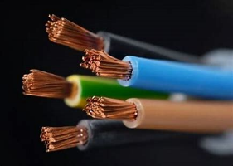
Circuit | Circuit | 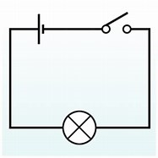
Insulator | Izolator | 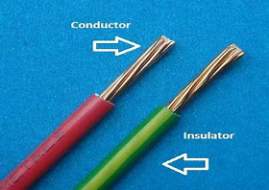
Motor | Motor | 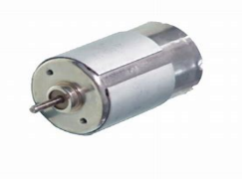
Component | Componentă | 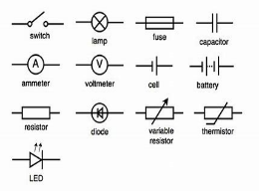
Connection | Conexiune | 

