This term our science topic will be ’electricity’.
Here is some key vocabulary that we will be using.
Key Vocabulary  English | Latvian | Picture
Electricity | Elektrība | 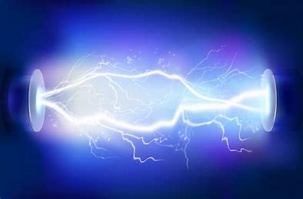
Appliance | Ierīce | 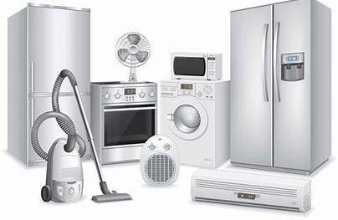
Mains | Maģistrāle | 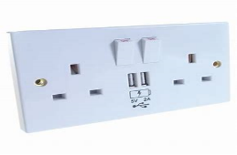
Conductor | Diriģents | 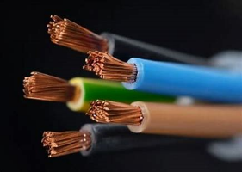
Circuit | Ķēde | 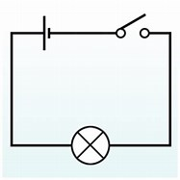
Insulator | Izolators | 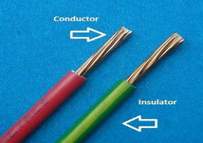
Motor | Motors | 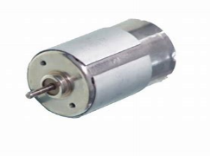
Component | Komponents | 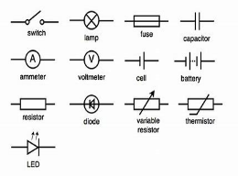
Connection | Savienojums | 

