This term our science topic will be ’electricity’.
Here is some key vocabulary that we will be using.
Key Vocabulary  English | Kurdish | Picture
Electricity | Elatrîk | 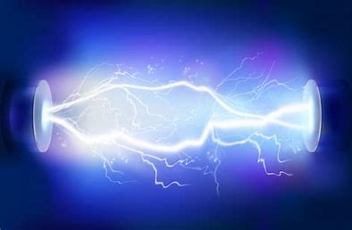
Appliance | Pêvdank | 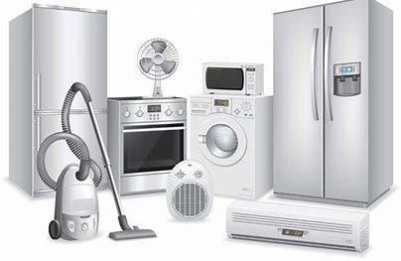
Mains | Mains | 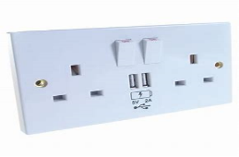
Conductor | Serek | 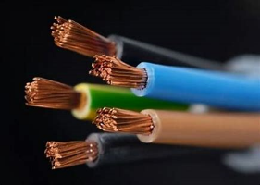
Circuit | Çerx | 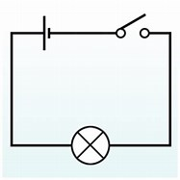
Insulator | Insulator | 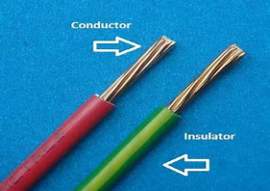
Motor | Motor | 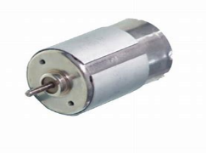
Component | Perçe | 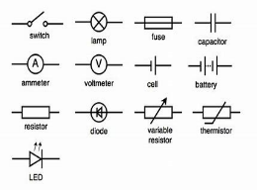
Connection | Têkêlî | 

