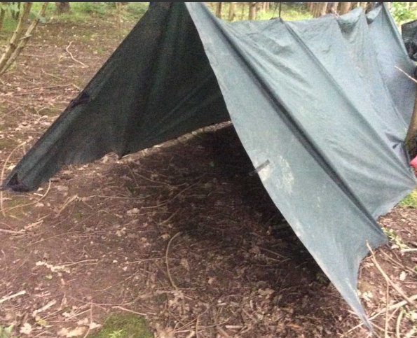  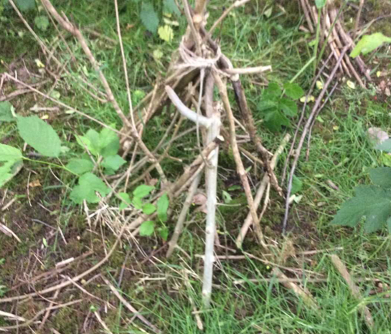  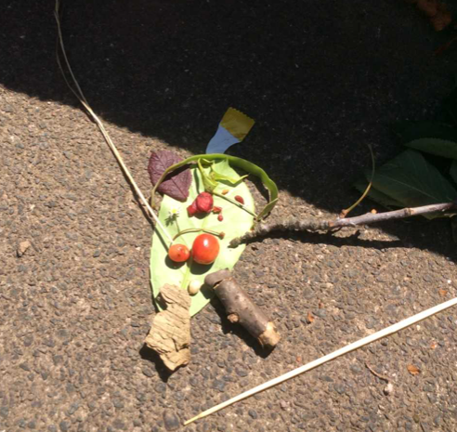 | 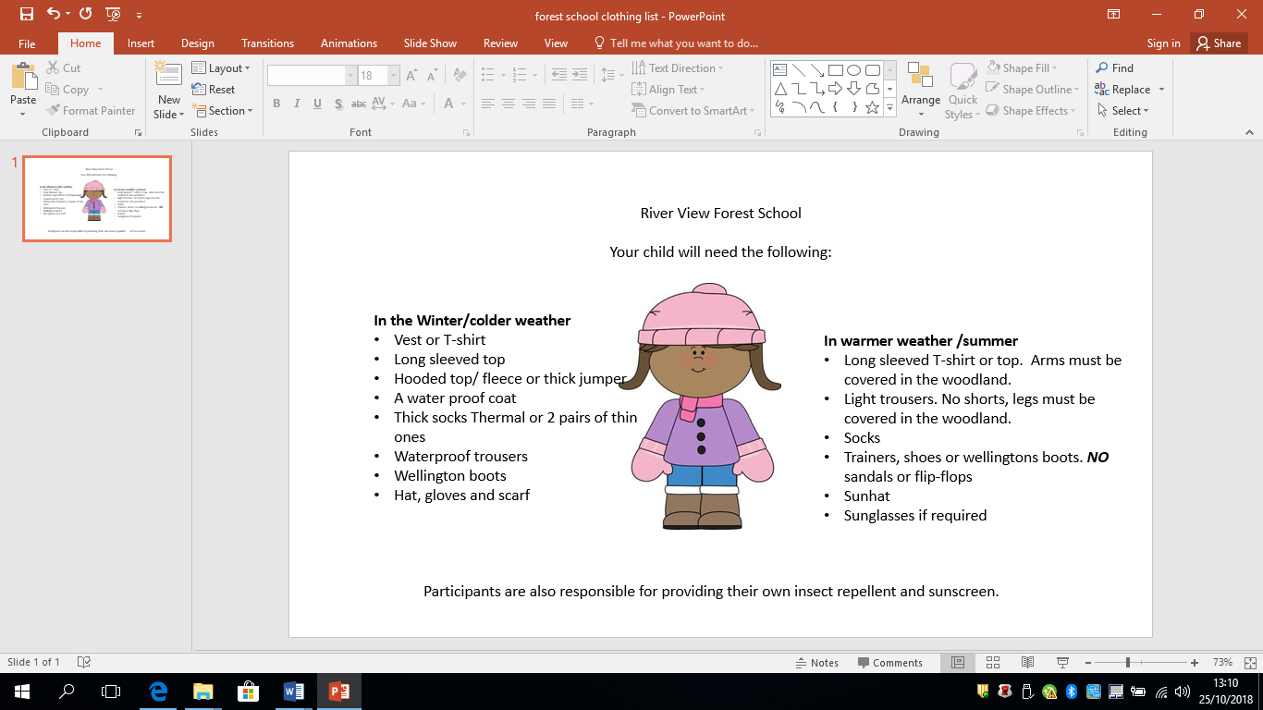 |  | River View Forest Schools  Information  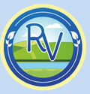

When?  As of September 2018, we have had qualified forest school leaders and teach children across the school throughout the year. Trent View Hub will start on Monday 15th September 2025. Please see reverse about appropriate clothing that will need to be bought into school. They will have forest schools on a Monday.  Children need to come to school wearing their forest school clothes. Please can they bring a spare set with them. Please send wellies in a spare bag.  What is Forest Schools?  Forest schools has key principles which state children benefit greatly from learning outdoors. Children will learn through first hand outdoor experiences and have the opportunities to take responsible risks to develop their learning.  We aim to encourage the children to become more independent, resilient and co-operative learners (which all links into our school’s RICHER values). | A need for structured play based activities will benefit the learning of children, (National Trust, 2012).  Forest schools will be taught on site (at the back of the building). Several trees and wild plants have been planted and an area is currently being developed.  What will they be doing?  Children will be introduced to imaginative activities and games. They will also be given opportunities to build dens and begin to use tools to craft objects. Children will have qualified adults (forest school level 3 and first aid qualified) and also their classroom staff to support them in a safe learning environment.  Forest school’s sessions will run throughout the year (in all weather conditions, the only exception is high winds). Children should wear clothes appropriate for the weather conditions. | Resources  Throughout the year the children will make and use a lot of resources. If you have any of the following items or find these items in the natural environment, feel free to bring them in;  - Sticks/twigs  - Plant pots  - Leaves  - Branches/tree wood  - Tree stumps  - Bark  - Shells  - Stones  - Conkers/pine cones etc  - Any plants, seeds or bulbs you no longer want or need  Any help/offerings would be greatly received.  Contact Us  If you would like any more information on forest schools, please contact Miss Martin.  Look out for forest schools pictures on the website soon!

